Trader Performance vs Market Sentiment Analysis
This analysis focuses on actionable insights rather than descriptive statistics.

1. Methodology
We analyzed the relationship between market sentiment (Fear/Greed index) and trader behavior using two datasets:
- Bitcoin Fear & Greed Index
- Hyperliquid trader transaction data
Steps performed:
- Data cleaning and preprocessing (handling mixed date formats, duplicates)
- Daily aggregation of trading metrics
- Feature engineering (PnL, win rate, trade size, frequency)
- Sentiment alignment and merging
- Segmentation analysis (trade size, trader frequency)

2. Key Visualizations
PnL Distribution across Sentiment:
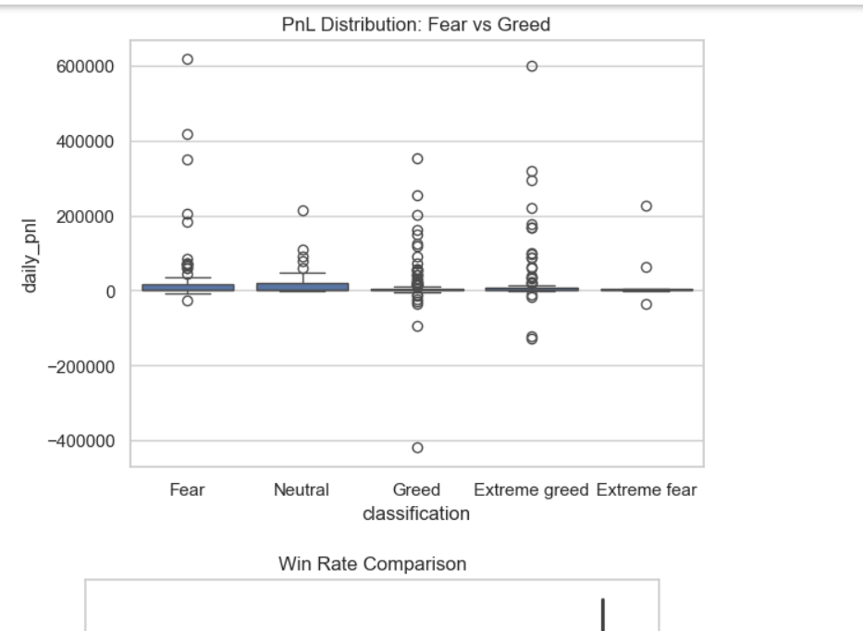
Win Rate Comparison:
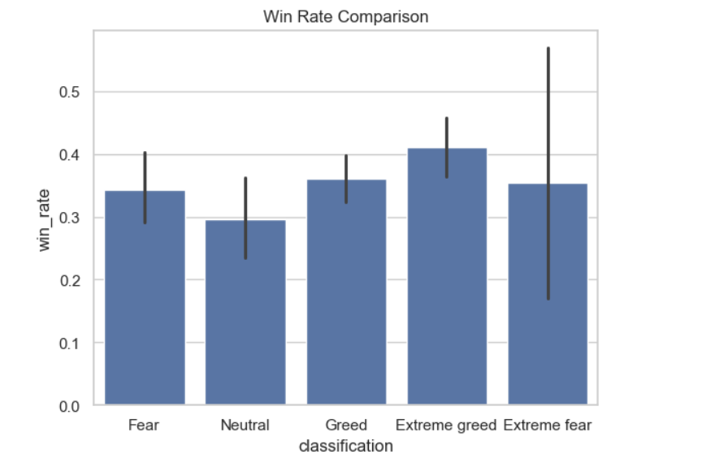
Trade Size by Sentiment:
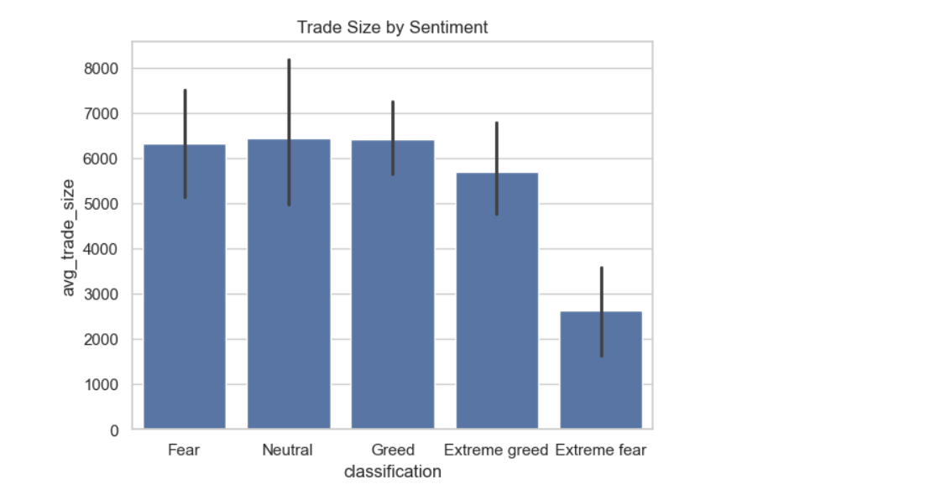

3. Key Insights
1. Traders perform significantly better during Fear periods (~33,866) compared to Greed (~9,099).
2. Lower trade sizes outperform higher trade sizes, indicating better risk-adjusted returns.
3. Frequent traders (~35,270) significantly outperform infrequent traders (~1,331).
4. Market sentiment influences behavior:
- Fear → cautious but profitable
- Greed → aggressive but volatile

4. Strategy Recommendations
- Reduce position size during Extreme Greed
- Increase trading activity during Fear markets
- Avoid large aggressive trades
- Focus on consistent execution over high-risk bets

5. Conclusion
Market sentiment plays a critical role in trader performance. Contrary to common belief, Fear markets provide better profitability, while Greed introduces instability. Adaptive, disciplined, and active traders achieve the best outcomes.

